**NAME:** KARTHIKA S

**MAIL-ID:** [karthikas@bitsathy.ac.in](mailto:karthikas@bitsathy.ac.in)

**INSTITUTION NAME:** Bannari Amman Institute of Technology ,

Sathyamangalam,Erode(District)

Tamil Nadu - 638401

**COURSE TITLE:** Applied Data Science

**PROJECT TITLE:** Effective Heart Disease Prediction Using IBM Auto AI Service

**OUTPUT SCREENSHOTS OF PROJECT:**

HEART DISEASE PREDICTION OUTPUT 1:

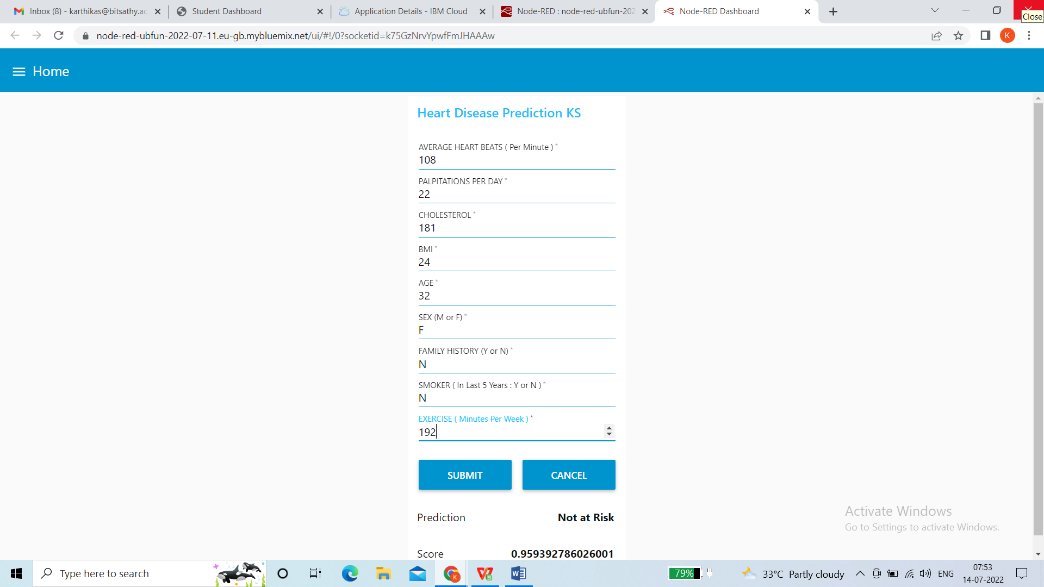

HEART DISEASE PREDICTION OUTPUT 2:

